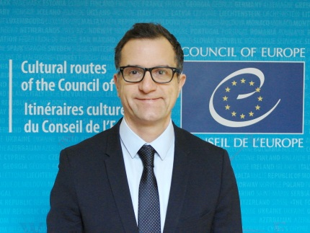 | Stefano DOMINIONI  Executive Secretary, Enlarged Partial Agreement on Cultural Routes - Council of Europe (EPA)  Director, European Institute of Cultural Routes (EICR)  Stefano Dominioni is Executive Secretary of the Council of Europe Enlarged Partial Agreement on Cultural Routes (EPA) and Director of the European Institute of Cultural Routes (Luxembourg). He is responsible for overseeing the certification by the Council of Europe of cultural routes in the field of European culture and heritage across its 47 Member States and the regular evaluation of the current 33 certified cultural routes. Dr. Dominioni ensures the 32 member States EPA Governing Board and Statutory Committee operations, management of the European Institute of Cultural Routes and coordination with the Cultural Routes of the Council of Europe. He is responsible for the implementation of Joint Programmes with the European Commission, and cooperation with another International Organisation such as UNESCO, OECD, UNWTO and OEI. During his career at the Council of Europe, he has worked for the Directorate General of Education, Culture and Youth and the Directorate General of Social Cohesion. He received his Ph.D. from Yale University, a Master Degree from the Université d’Aix-Marseille and a B.A. from the University of Milan.

